# Abstract

Periodic presumptive treatment (PPT) is an intervention which can quickly reduce prevalences of a curable STI. PPT could be used to lower the prevalence of STIs which increase HIV spread. Some modelling has been done in this area, and found that decreases in HIV are possible using PPT in high-HIV settings, but little modelling has investigated whether this decrease is still possible in a country with an intermediate level of HIV. A deterministic compartmental model was built to model the effect of PPT on an STI, and the results were fed into an existing model for HIV, to estimate the change in incidence of HIV. The sensitivity of the model to some assumptions was tested. Significant decreases in the STI prevalence among the whole population are possible, but much more so in urban settings. PPT provided to FSW across the whole country at high (>50%) coverages every two months can decrease national levels of the targeted STI moderately (>25%), but significantly in urban areas (>50%) over 10 years. Providing PPT only in urban areas achieves a similar level of effect (>45%). This causes a decrease in HIV incidence of 4%-6%, or 6%-8% in urban areas.

# Introduction

Papua New Guinea (PNG) is a small developing island nation just north of Australia, with a population of 7.3 million people. It has an HIV prevalence of 1 in 2000, the highest in the Pacific and five times the prevalence in Australia. HIV is an uncurable sexually transmitted virus, which attacks and eventually destroys T cells, a key part of a person’s immune system. AIDS, the consequent lack of T cells, is the main cause of death at PNG’s main hospital. Reducing the number of people who acquire HIV is thus a priority for some policymakers.

There are certain sexually transmitted infections (STIs) which make a person more likely to transmit or acquire HIV. The two major STIs in PNG of which this is most true are herpes simplex virus 2, and syphilis. These STIs increase a person’s likelihood of acquiring or receiving HIV by 2 to 5 times, a called the *HIV cofactor*. These STIs are very common in PNG. For example, syphilis occurs in one in 20 men, one in 12 women and 1 in 3 female sex workers (FSW) {Vallely, 2010 #9}. By way of comparison, syphilis occurs in 1 in 14,000 people in Australia, predominantly among MSM. Syphilis, like many STIs, is curable if treated early enough. Thus, lowering levels of syphilis is of direct benefit to the population, but is also a possible method of lowering the incidence, or number of new cases, of HIV.

STIs apart from HIV also impose costs on PNG's health system. Syphilis is fatal in many cases, while chlamydia, an STI for which evidence of an HIV cofactor is weaker, leads to blindness and infertility. Making these STIs harder to treat, in many cases these STIs are asymptomatic. Moreover, for some STIs, such as chlamydia, there is no quick and cheap test that can be administered in the field. The only existing tests require laboratory equipment which is not available at all clinics in PNG.

In Australia, this delay in receiving results would not matter, since people would simply make another appointment and receive treatment shortly after they were notified of a positive diagnosis. In PNG this would be less practical. Only 50% of the population has a mobile SIM, and many people might be unwilling to receive notification about STI results using a shared phone. Large numbers of people diagnosed may not receive their diagnosis, or not receive it for a long time. Moreover, many people have to travel long distances to reach a clinic. Some people also find the clinic environment hostile, and feel judged by the people there, and so want to minimise their visits to clinics. Thus, people who have received a positive diagnosis, may also never return for treatment, or may only return later, after they have had a chance to infect others.

An alternative treatment program for chlamydia involves treating people immediately when they come into a clinic, without waiting for test results. This is called *periodic presumptive treatment* (PPT). PPT is typically provided to high-risk sub-populations, especially FSW. If enough people are reached, significant feedback will develop between the prevalence among people receiving treatment and the prevalence among their partners, and will also filter out into the wider community. This intervention has been used against chlamydia in several large-scale trials, and has proven effective. A chlamydia PPT program could be easily and cheaply combined with a PPT program for STIs such as syphilis with a clearer effect on the risk of HIV transmission. PPT would then become a combined intervention targeting all three of the hard-to-test STI, the high-cofactor STI, and HIV. This paper ignores the hard-to-test STI, and focuses on the effect of the decrease in the high-cofactor STI on HIV.

Several authors have discussed the use of PPT as an HIV reduction measure, but only one trial has been conducted, with a power low enough that a meaningful effect could have been missed. Thus, modelling is required to determine whether a meaningful effect is realistic. The only model that we have found published to date is (Vickerman et al., 2010). This paper is a model for the impact of treating chlamydia and gonorrhoea on HIV levels in an African context. Vickerman et al. found that an intervention which reached 10% of FSW could reduce HIV incidence by 10% in 3 years, which would be a very positive outcome. However, HIV and high-cofactor STI levels in Africa are much higher than in PNG. No modelling has been carried out in a setting with HIV levels close to those in PNG. This paper aims to perform a pilot study for such a model.

# Methods

In this paper, we develop a dynamical deterministic compartmental homogenous mixing model for a curable STI with a high HIV cofactor. We calibrate the steady state of our model to the current prevalence of syphilis in PNG. Although there is enough data to model specific diseases differently, we assume that there is only one STI with a significant HIV cofactor against which our intervention will be effective. We assume that all other STIs with a non-trivial HIV cofactor have the same cofactor as the STI our intervention is targeting, and that their prevalence will remain constant during our intervention. We calculate a combined prevalence by assuming the cofactor STIs are independent, and input them into an existing HIV model to forecast the impact of PPT on HIV. Our model structure is shown in Figure 1. Note that our model structure does not allow for any impact of HIV on our STI levels. There is some evidence that HIV affects disease progression for STIs such as syphilis, but the evidence is not strong.

Figure : Diagram showing the cascading structure of our model, where STI prevalences are calculated first, then used in calculating HIV incidence.  


Our HIV model was taken from Gray et al., 2010, as employed in Vallely et al. (2014). We modified some model parameters in line with updated information. As HIV clinics have expanded into more areas of PNG, HIV prevalence estimates have fallen. UNAIDS, the UN peak body for HIV research, believes that as clinics have become accessible for more of the population, the data obtained from them is becoming a closer and closer representation of the true level of HIV, rather than reflecting an actual fall in HIV levels. As such, the prevalence estimates in the HIV model are too high. In addition, the model used an STI cofactor of 5, at the top of the confidence interval provided in [], [] and []. We opted to reduce this to 2.5, again upsetting the calibration of the model. To compensate, we adjusted the HIV transmission probabilities, and also the diagnosis rates. A full description of our changes is provided in Supplementary Table 1.

The HIV model, both with its original parameters and with our updated parameters, suggests that HIV incidence is already falling. We thus measure the proportional fall in HIV incidence relative to the projected incidence of HIV for that period assuming no PPT, which we called the impact of PPT on HIV incidence. Because our STI model is initially in steady state, the proportional decrease in curable STI prevalence is the same whether it is compared to the projected STI prevalence at that time or to the initial STI prevalence. We call this decrease the impact of PPT on curable STI prevalence.

## Model for targeted STI

Our STI model uses two non-interacting regions and four sub-populations. The HIV model divides into rural and urban regions, so our STI model does the same. Baseline STI prevalences are all higher in the rural region than in the urban region. Also following the HIV model, our STI model divides the population into female sex workers, general females, general males, and men who have sex with men and women (MSMW). Following our HIV model, we merge men who have sex exclusively with men into this category. PNG also has low levels of injecting drug use, so we do not model this population. There is little research targeting MSMW in PNG, making it hard to model them as a sub-population, so we assume their STI prevalence is halfway between those of general males and general females. Our baseline STI prevalences were as shown in Table 1.

Table : Prevalences used as steady state for STI model

|  |  |  |
| --- | --- | --- |
|  |  |  |
|  |  |  |
|  |  |  |
|  |  |  |
|  |  |  |

Our STI model was a SIPS model, where people could be susceptible, infected, or protected by PPT. We ignore any protection from any source other than PPT, so a person can only be in state if they have received PPT. Thus, when no PPT is being applied, the model collapses to a SIS model. We designed it such that that when PPT coverage was 0, the model collapsed to a SIS model. We let and denote the proportions of sub-population who are susceptible and infected, respectively, where the subscript is one of for FSW, for general females, for general males, or for MSMW. The equations are identical in structure for FSW, general females and general males, and slightly different for MSMW. Note that since and are proportions, we have . Our model equations for FSW are presented in Equation 1.

Equation : STI dynamics for FSW not receiving PPT

Infected FSW stop being infected at the constant rate . This rate accounts for existing treatment for the STI. It also accounts for deaths and new entries into the sexually active population, where new entrants have a lower level of the targeted STI than people leaving the sexually active population. A proportion of mothers will seek prevention of mother-to-child transmission of their STIs, which reduces the proportion of infected newborns below the proportion of mothers infected. There is a chance that an infected and untreated mother will not pass on her STI to an unborn child. An uninfected child is also more likely to survive birth and infancy than an infected child. If the targeted STI has serious symptoms, like syphilis, then the death rate among the infected may also be higher than among the uninfected. Thus, loss and replacement among the population reduces the proportion of the population infected.

Susceptible FSW became infected at a variable rate , which depended on the infection rate among males. is the maximum rate at which FSW would be infected if all of their partners were infected. Since our paper is only a pilot study, we do not calculate our STI transmission probabilities from observed quantities, rather we fit our transmission probabilities per period to the desired steady state. The infection rate is simply this infection rate times the probability that a randomly selected partner of an FSW is infected. We assume that general males and MSMW have the same levels of sexual partnerships with general females and FSW, so is just the proportion of males who are MSMW. Since we used a small time step when we implemented the model, the probability that two events happen to a person in one time step is negligible (10-6).

These equations are the same for general males and general females. For general females, we again use the partner infection probability . For general males, we replace and with and , and we replace with , the probability that a random sex act by a general male will be with a FSW, which must be adjusted for FSW performing more sex acts with general males per person than general females perform. For MSMW, we took a slightly different approach. We added the probability that an MSMW will acquire an STI from a female, which we assumed is the same as the probability that a general male will acquire an STI, to a separate probability that an MSMW will acquire an STI from an MSMW. Thus, took the form shown in Equation 2, below.

Equation : Infection rate equation for MSMW

We generalised from these equations when we added PPT.

We assumed that under PPT, a fraction of FSW would be enrolled at random. If an FSW was enrolled, they would receive PPT at a rate per month, whenever they were susceptible or infected. They would then immediately enter the protected state P, which they would leave at a constant rate , to become susceptible again. Otherwise, they would follow the same SIS dynamics as before. The dynamics are described in Equation 3, below.

Equation : STI dynamics for FSW receiving PPT

In reality, people are likely to seek treatment more when they know they have just engaged in risky behaviour, or when it is a longer times since their last visit. People in PNG have quite high levels of knowledge about risky behaviour. Thus, the rate of PPT should be higher among infected people and lower among susceptible people. However, this effect is by nature very hard to prove experimentally, so we disregarded it. We also assumed that people's risk-taking behaviour such as condom use would not increase because they felt safer (known as *compensatory risk-taking*). This has not been observed in practice, although it should remain a concern in implementing PPT [WHO guide to PPT].

We calculated the infection rate for males using the weighted average of the infection levels among FSW receiving treatment and FSW not receiving treatment.

# Results

shows that substantial impact on STI prevalences can be achieved among the FSW reached by PPT even at moderate frequencies (treatment once every two months) and coverages (50%). A large impact on STI prevalences among all FSW is possible, particularly at higher coverages. There is even a significant decrease in STI prevalences in populations other than FSW: populations other than FSW experience a relative decrease in STI prevalence between 45% and 50% as large as the relative decrease that FSW experience, and a correspondingly large decrease in HIV prevalence. Under the other intervention we have considered, this decrease varies between 43% and 51%.

Figure : Effect of PPT on STI prevalences among a. FSW receiving PPT, b. all FSW, c. the whole population. d. shows the effect on STI prevalences for each sub-population as a proportion of the initial prevalence.

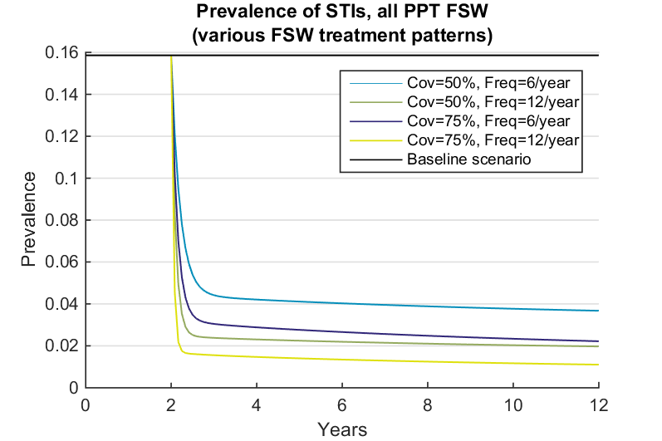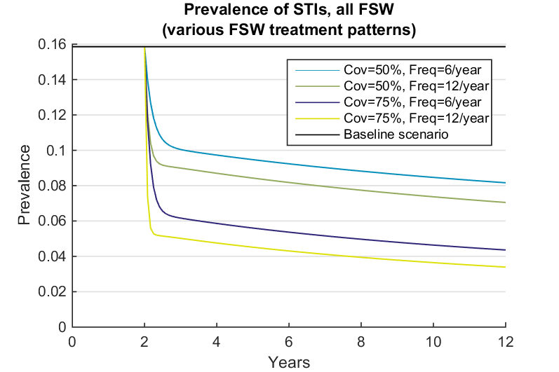 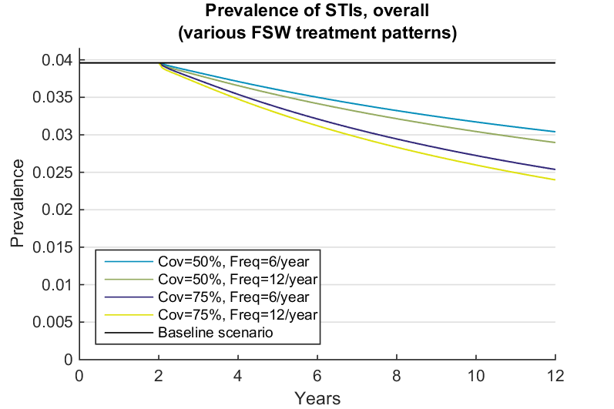 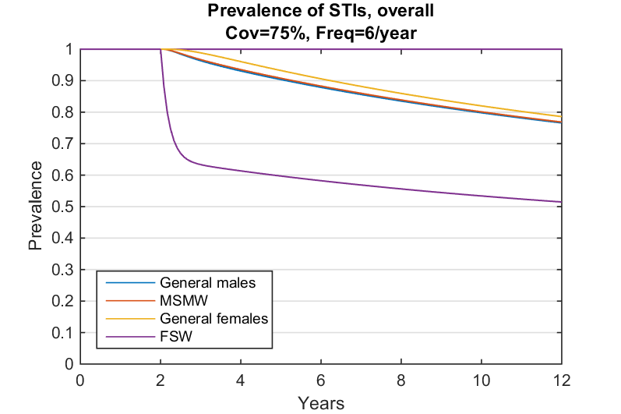

shows that there is a much greater decrease in STI prevalence in an urban setting than in a rural setting. In a rural setting, STI prevalences fall only slightly, which causes an almost insignificant drop in HIV. However, in an urban setting, all of the interventions we are considering bring STI prevalences close to 0. This has a correspondingly greater impact on HIV prevalences. Because PNG's population is largely rural, the overall impact of the interventions we have considered is small.

Figure : a-c: Effect of PPT on STI prevalences in PNG a. overall, b. in rural setting, c. in urban setting.  
d-f: Effect of PPT on HIV prevalences d. overall, e. in rural setting, f. in urban setting

## Sensitivity analysis

Increasing the prevalence of non-curable STIs by 10% did not affect curable STIs as expected, and decreased the impact of our intervention on HIV incidence by 15%. However, this change produced HIV historical estimates significantly smaller than current data suggests is reasonable. Likewise, decreasing the prevalence of non-curable STIs by 10% increased the impact of our intervention on HIV incidence by 25%.

Increasing the curable STI prevalences to which we fitted our infection rates , and holding non-curable STI prevalences constant, caused a decrease in the impact on curable STIs by 5%. This increase in baseline STIs increased the HIV prevalence at baseline by 40%, but also increased the proportion of HIV attributed to STIs. The increase in baseline prevalence caused an increase in HIV prevalence at baseline which reduced the effect of PPT, and this effect outweighed the increase in the proportion of HIV attributed to STIs. Accordingly, HIV impact estimates fell by 8% when we increased STI prevalences.

Decreasing the starting STI prevalences by 10% caused an increase in the impact of PPT on STIs by 3%. However, in this case, the HIV prevalence baseline predictions fell by roughly 65% at its minimum. STI levels no longer contributed as much to the intervention, and the impact size fell by between 24% and 27%.

Decreasing the duration of STI infection by 10%, and correspondingly increasing the infection rates, caused the impact on STI levels to fall by 8%. This decreased the effect on HIV by 9%. Increasing the duration by 10% caused the impact on STI levels and HIV incidence to rise by 6% each.

Unfortunately, changing the HIV cofactor caused the HIV baseline model to become wildly uncalibrated. We were unable to find a sensitivity to the HIV cofactor. [] found the cofactor for syphilis was between 2 and 5, so our cofactor used here is quite conservative. No other parameters had an impact on STI prevalences or HIV incidence of more than 5% when increased or decreased by 10%. They are listed in Supplementary Figure 1.

Figure : Effect on impact size of univariate changes in parameters, for parameters with large effects 1. on STIs prevalences 2. on HIV incidence

# Discussion

Our analysis had several limitations. Fundamentally, our paper was based on a model, and as such was only as good as our data values and assumptions. We expect our general insights would hold if our parameter values were wrong, but there are several fundamental assumptions which we have not tested. Our model structure prevented us testing the effect that any impact of HIV on STI progression might have on our results. While evidence for such an impact is weak, stronger evidence of such an effect may emerge, and that may affect the validity of our results. We have also not included any information about the disease progression of the STI we are targeting. If the infection is more infectious closer to the time the infection was acquired, and less infectious later, then this would decrease the impact of PPT, since it would effectively reduce the duration of protection, We have also not modelled for any long-term resistance to the STI, such as is possible for some STIs including chlamydia.

We have assumed homogenous behaviour. This probably made our results overly optimistic since there may be highly sexually active sub-communities of males, females and FSW which maintain higher STI prevalences, producing the same reduction in PPT effectiveness against the STI that was observed when we increased the overall STI prevalence.

We have ignored some specific demographic effects which a future model should include. There are several occupations where workers, typically male, engage in higher levels of casual sex, and travel often. These occupations often have elevated STI prevalences, which would affect our results. There are datasets for many of these occupations, such as transport workers, miners and soldiers, and they could be included in future versions of this model. We have also not included the effects of migration between areas where PPT is provided and areas where it is not, nor between communities with high STI prevalences and communities with lower STI prevalences.

We assumed no difference in disease duration between genders, or between urban and rural settings. Future work should also attempt to derive transmission parameters from observed inputs, rather than from prevalences. We have assumed that STI cofactors are not additive. We have also not accounted for congenital syphilis in a manner which allows us to consider the effects of prevention of mother-to-child transmission.

We have not considered the consequences of ending our program. Pourbohloul et al, 2003 suggests that PPT cause a quick rebound when it is ended. Most PPT programs are integrated with sexual health and safety awareness programs, condom promotion or other HIV reduction programs, and these are often able to keep STI levels down (Steen et al., 2012). We have not considered the effects of such a program.

We have accounted for antibiotic resistance among curable STIs in a very simplified manner. While syphilis has remained sensitive to penicillin for centuries, gonorrhoea, another STI which is often affected by PPT, can easily develop resistance to the most common antibiotic provided for PPT, azithromycin. Modelling could estimate the risk that PPT would cause such resistance to spread.

The model indicates that substantial decreases in STI prevalences can be achieved quickly among FSW reached. With sufficient coverage (>50%) and frequency (>0.5 per month), this decrease will slowly propagate into the entire population (~10 years for a 25% decrease). In urban settings, where FSW account for more of the current STI infections, this decrease is much faster, and achieves a much greater effect in the long term.

The effect this has on HIV incidence is on the order of 4%-6%. For urban residents, this decrease is 6%-8%. This implies the decrease in new HIV cases is within an order of magnitude of the number of people treated. This again takes longer to develop. In addition, the prevalence of curable and non-curable STIs, the duration of STI infection and the HIV cofactor are significant sources of uncertainty in our results. In addition, there are several effects, such as migration, births and deaths, which we have ignored.

We found that increasing the frequency of treatment increases the impact of PPT on STI prevalence and HIV incidence until around 1.5 doses per month, where the change in impact becomes smaller. Increasing coverage of treatment can bring eventually bring STI prevalence very low in urban settings, but not in rural settings. When around 75% of FSW are receiving treatment, the FSW STI prevalence falls near zero, but the general male and female populations delay the infection levels for several years no matter how low the FSW prevalence falls. In rural settings, FSW account for so little of the STI infections initially that even when the FSW prevalence falls to 0, the general male and female populations reach a new equilibrium STI prevalence away from 0. The expected number of non-FSW new infections for a single infected general male or female is greater than 1, so the STI's prevalence does not converge to zero in rural settings.

We found that increasing the coverage of PPT was more important than increasing the frequency with which it is administered. While there is a slightly higher prevalence of STIs among FSWs receiving PPT if PPT is administered to 50% of FSWs every month than if it is administered to 75% of FSWs every two months, the increase in the number of people treated outweighs the between-scenario difference in infection levels, even accounting for the fact that the people not receiving treatment have an intermediate STI prevalence rather than their initial prevalence. This is consistent with Vickerman et al.'s results, although their paper does not emphasise the fact.

Our analysis was conducted assuming a relatively low cofactor (2.4) for a disease such as syphilis. Our HIV model was cumbersome to adjust to fit data, and a great research investment would need to be made to bring thhe HIV model in line with data, assuming a higher HIV cofactor. This adds a measure of pessimism to our model, although it is not clear how much. 2.5 would be a more optimistic cofactor for chlamydia or gonorrhoea, the STIs most commonly targeted by PPT interventions to date. However, a syphilis intervention could be combined with a PPT intervention. The fact that our model results suggest PPT in PNG would be relatively insensitive to a small change in frequency of PPT means that our results can be easily generalised to any form of rapid point-of-care (RPOC) testing with a moderate failure rate combined with same-day treatment. A combination of PPT for chlamydia and RPOC testing could have significant benefits in PNG.

Although our results may be optimistic because of our homogenous mixing and behaviour assumptions and our lack of detail around STI progression, our results still suggest that providing PPT to FSW in PNG could be a plausible combined intervention for STIs and HIV in settings with a high proportion of FSW, if PPT can reach a high (>50%) proportion of them. A reduction in HIV incidence is likely to be seen among the whole population, which will increase over a number of years, at a faster rate than currently projected. An intervention could involve a combination of RPOC tests for STIs for which they exist, and PPT, and should involve other HIV control measures.